# Lab 7

## Question [clo:6][5+5]:

1. For a number stored on Ax register , create a procedure that display it on screen in a number system whose base is 6 (For checking 27d in this number system will be displayed as 43)

**CODE:**

org 100h

.data

x db 0

pro dw 10h

remainder db 0

.code

main proc

mov ax,27d

mov bl,6d

call conv

ret

conv proc

top:

div bl

xor dx,dx

mov dl,ah

push dx

inc x

mov ah,0

cmp al,0

jne top

print:

pop dx

mov ah,2

add dx,48

int 21h

dec x

jnz print

Ret

**OUTPUT:**

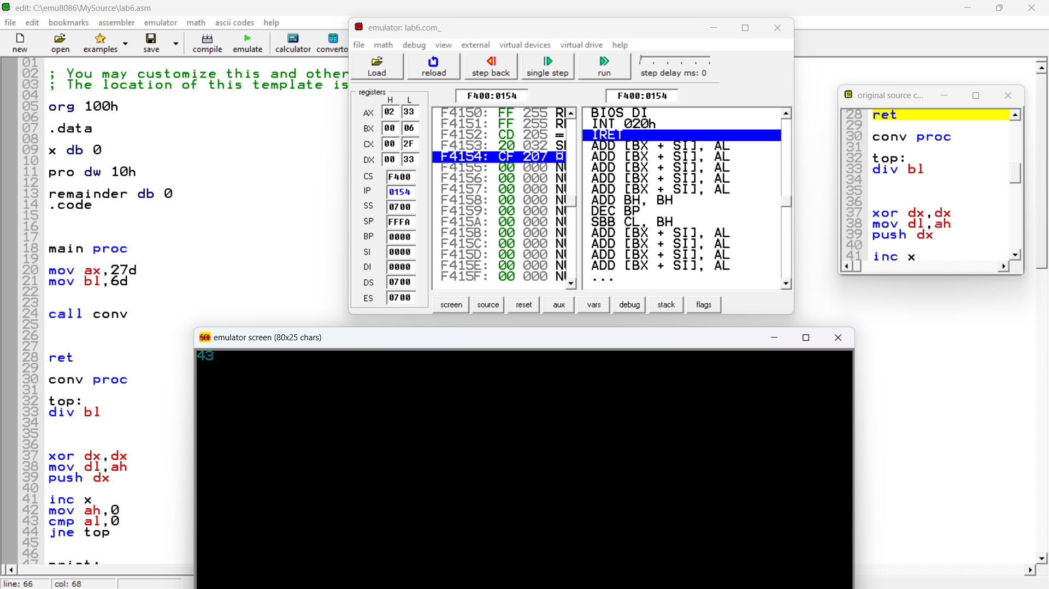

2. Make a procedure that asks user to enter a number , in a number system of base 6, and store the value of corresponding number in register AX

**OUTPUT:**

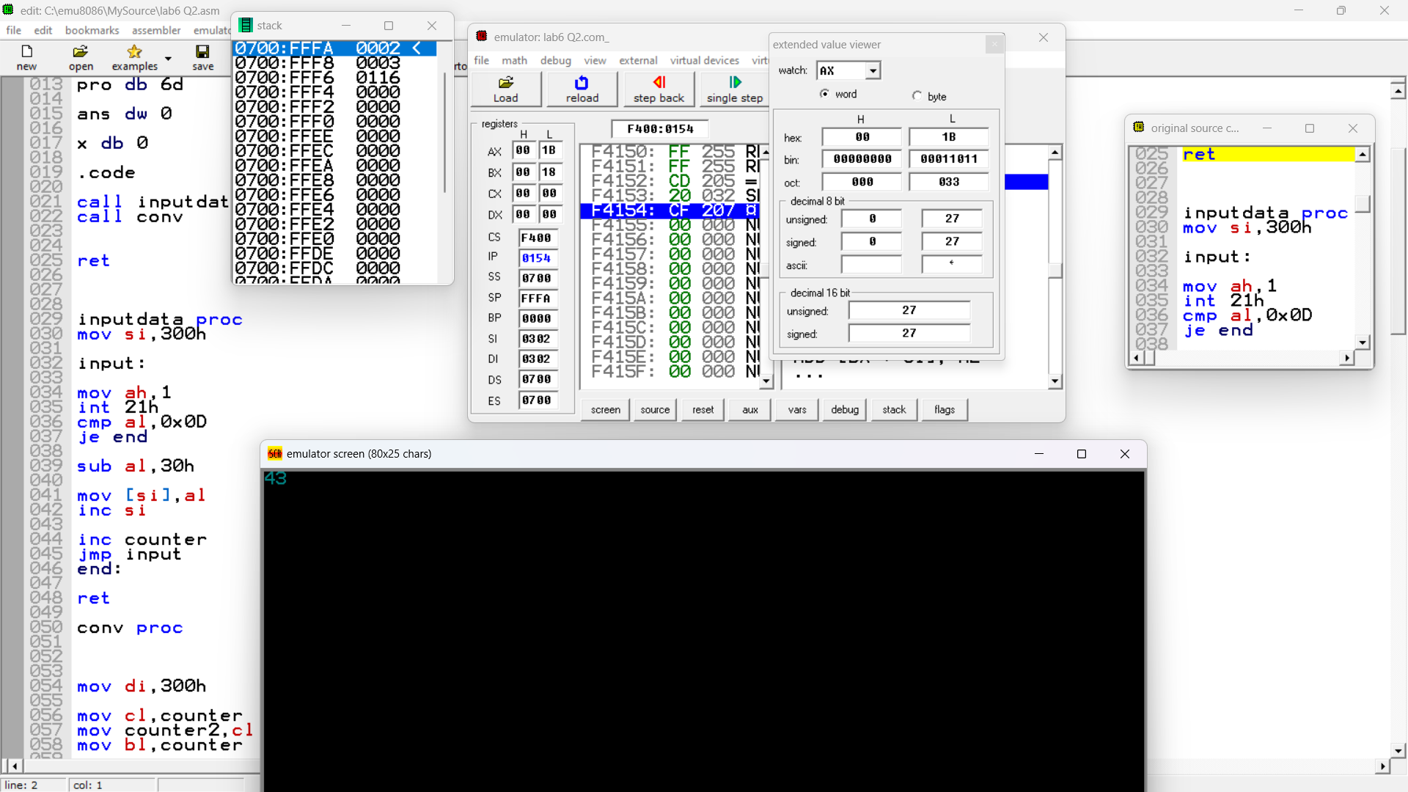

**CODE:**

org 100h

.data

counter db 0

multiplier db 6

ans dw 0

.code

main proc

call input

call calc

ret

input proc

mov si,250h

top:

mov ah,1

int 21h

cmp al,0x0D

je exit

sub al,30h

mov [si],al

inc si

inc counter

jmp top

exit:

ret

calc proc

mov si,250h

top2:

mov ax,ans

mov al,[si]

cmp counter,1

je down

mul multiplier

down:

add ans,ax

inc si

dec counter

jnz top2

mov ax,ans

ret